Lab Statement 1

1. HTTP, SNMP, TCP, DNS
2. 10:29:47.862531000- 10:29:47.838388000 = 0.024143 seconds
3. No, the page couldn’t be found (Error 404).
4. Both are running HTTP 1.1
5. en-us, en
6. Computer IP: 192.168.1.102

gaia.cs.umass.edu IP: 128.119.245.12

1. Computer MAC Address: 00:08:74:4f:36:23

Server MAC Address: 00:06:25:da:af:73

1. Sending port number: 4127

Receiving port number: 80

TCP port 80, most often used by Hypertext Transfer Protocol

1. 200 in first response message and 404 in second response
2. Tue, 23 Sep 2003 05:29:00 GMT
3. 73+1071=1144 bytes
4. No
5. No

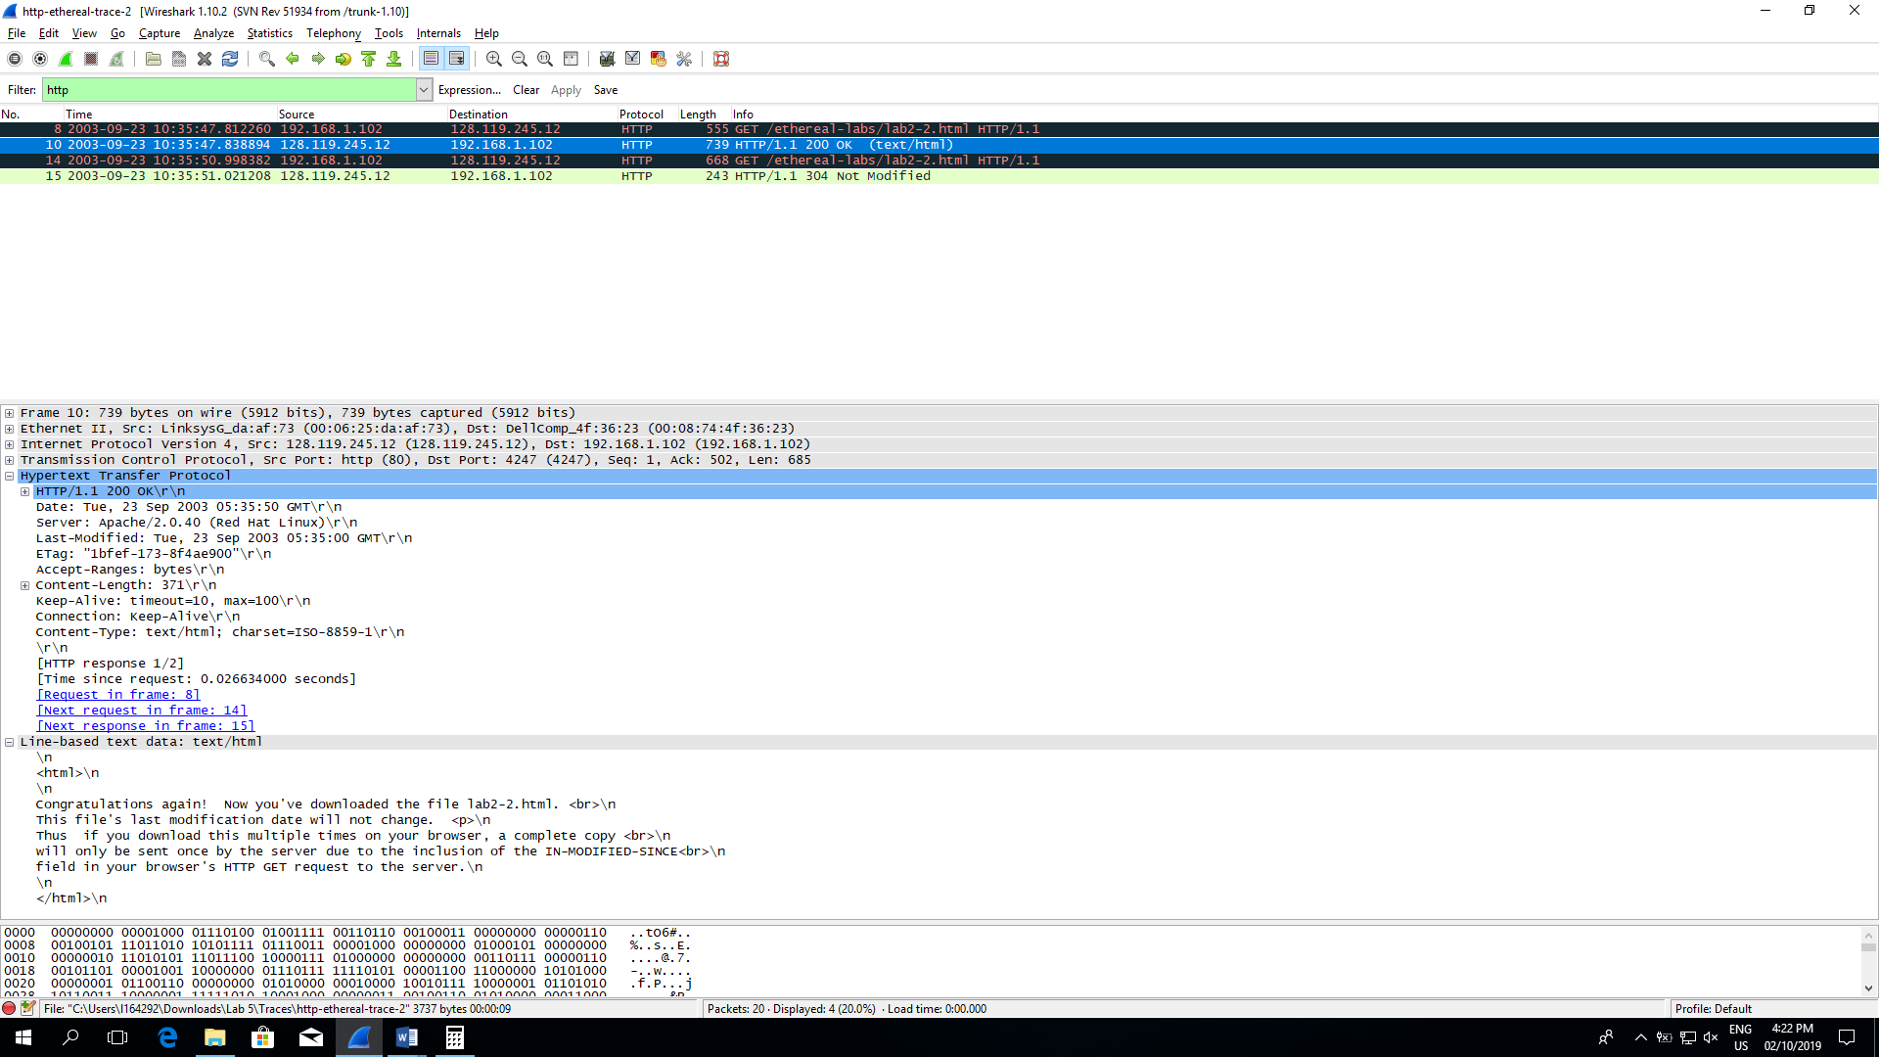

1. Yes.

“Tue, 23 Sep 2003 05:35:00 GMT\r\n”

The If-Modified-Since request HTTP header makes the request conditional: the server will send back the requested resource, with a 200 status, only if it has been last modified after the given date. If the request has not been modified since, the response will be a 304 without any body; the Last-Modified response header of a previous request will contain the date of last modification.

1. 304 Not modified

Nope, it returns a 304 response without any body as mentioned above.

Lab Statement 2

1. One
2. 8
3. 10
4. 200 OK
5. 3

10, 11, 13